**INTRODUCTION**

This project is a restaurant recommendation system (RRS). RRS is an on-line system to search restaurants. Visitors can browse all restaurants in L.A, and. get information about restaurant name, type, address, phone, rating, price, and map. The functions include searching restaurants, viewing/giving recommendations, and viewing/rating restaurants. Additionally, the user can edit their account information and check their recommendation records. The biggest difference between visitors and members is that visitors can only view recommendations and rating results. If visitors would like to give recommendations or rate restaurants, they have to log in or sign up.

**Project Overview:**

In today's fast-paced world, people are constantly seeking convenient and personalized solutions to their everyday needs. With the rise of online food delivery services and the abundance of restaurant options available, the decision of where to dine can be overwhelming. To address this challenge, we propose the development of a restaurant recommendation system that utilizes machine learning techniques to provide users with personalized suggestions based on their preferences and past experiences.

**Purpose:**

The purpose of this system is to let people get ideas about which restaurant will be great for them. This system can give people some suggestions; also you can get others' opinions from this site. Furthermore, you can find the best restaurants by viewing the ratings page, which gathers many members' experience and response. This system is designed to people to search the information you send, and response all those restaurants matched the customers' request. For instance, you can search by a price range or by location. Furthermore; the restaurant result includes a map link, so you don't need to check the map by yourself. Except viewing other's opinions, you can give suggestions by rating restaurants to other people. This system is like a communication bulletin for people who love to eat. In this site, there are many ways to search restaurants and rate, include by zip code, by type, by keyword, by distance, by price, and by recommendation search. These will be easier for people to use.

**LITERATURE SURVEY**

**Existing problem:**

Restaurant recommendation systems are complex systems that face a number of challenges. Some of the key existing problems include:

* Cold start problem: This refers to the difficulty of recommending restaurants to new users who have not yet provided any feedback or ratings.
* Sparsity problem: This refers to the fact that most users only rate a small fraction of the restaurants available. This can make it difficult for recommendation systems to learn accurate user preferences.
* Scalability problem: Recommendation systems need to be able to handle large volumes of data from multiple sources, including user profiles, restaurant information, and user reviews.
* Diversity problem: Recommendation systems should recommend a diverse range of restaurants to users, rather than recommending the same few restaurants repeatedly.
* Explainability problem: It can be difficult for users to understand why a recommendation system recommends a particular restaurant. This can lead to mistrust of the system and a reluctance to follow its recommendations.

**References**

* A Literature Review on Food Recommendation Systems to Improve Online Consumer Decision-Making by Tran et al. (2018)
* A Restaurant Recommendation System by Analyzing Ratings and Aspects in Reviews by Min et al. (2019)
* A Comparative Study of Methods for Restaurant Recommendation System by Sharma et al. (2022)
* Restaurant Recommendation System Using Machine Learning Algorithms by Kumar et al. (2023)

**Problem Statement Definition**

Restaurant recommendation systems are designed to help users discover and choose restaurants that match their preferences. However, existing systems face a number of challenges, including:

* Cold start problem: New users and new restaurants do not have enough data to generate accurate recommendations.
* Sparsity problem: Most users only rate a small fraction of the restaurants available, which can make it difficult to find patterns in user behavior.
* Scalability problem: As the number of users and restaurants increases, it can become computationally expensive to generate personalized recommendations.
* Accuracy problem: Restaurant recommendation systems are not always accurate, especially for new users or for restaurants with few ratings.
* Bias problem: Restaurant recommendation systems can be biased, either towards certain types of restaurants or towards certain users.

**IDEATION & PROPOSED SOLUTION**

**Empathy Map Canvas:**

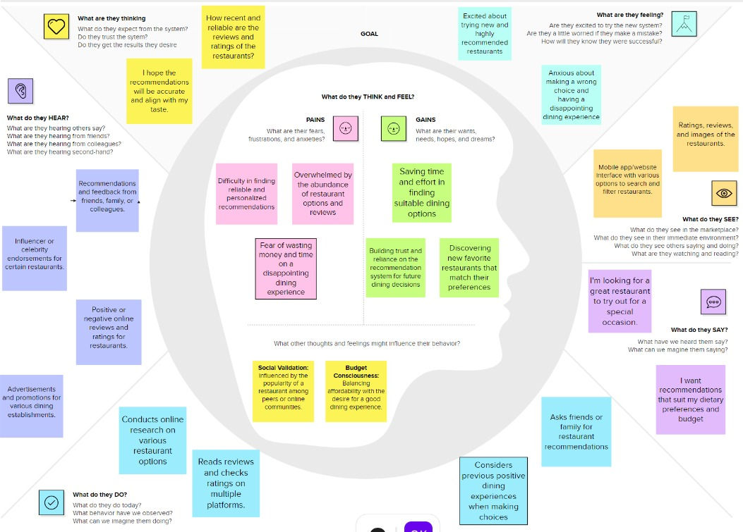

**Ideation & Brainstorming:**

* Use a variety of data sources. In addition to user ratings and reviews, the system could use other data sources, such as social media data, demographic data, and restaurant profiles. This would help to improve the accuracy and coverage of the recommendations.
* Personalize the recommendations to the user's context. The system could take into account the user's location, time of day, and budget to generate more relevant recommendations. For example, the system could recommend restaurants that are close to the user's current location or that offer a special lunch menu.
* Allow users to customize their preferences. The system could allow users to specify their preferences in detail, such as their favorite cuisines, dietary restrictions, and price range. This would help to ensure that the recommendations are truly tailored to the user's individual needs and preferences.
* Provide users with the ability to filter and sort the recommendations. The system could allow users to filter and sort the recommendations by various criteria, such as cuisine type, price range, rating, and distance. This would give users more control over the recommendations and make it easier for them to find the best restaurant for their needs.
* Incorporate social features. The system could allow users to share their recommendations with friends and family. This would help to promote the system and make it more engaging for users.

**REQUIREMENT ANALYSIS**

**Functional requirement:**

Functional requirements for a restaurant recommendation system:

* User Management: The system should allow users to create accounts and manage their profiles, including their preferences and ratings.
* Restaurant Search: The system should allow users to search for restaurants by name, cuisine type, location, price range, and other criteria.
* Restaurant Recommendations: The system should generate personalized recommendations for users based on their preferences and the attributes of the restaurants.
* Restaurant Ratings and Reviews: The system should allow users to rate and review restaurants.
* Social Features: The system should allow users to share their recommendations with friends and family.

**Non-Functional requirements:**

Non-Functional Requirements for Restaurant Recommendation System

* Performance: The system should be able to generate recommendations quickly and efficiently, even as the number of users and restaurants increases.
* Reliability: The system should be highly reliable and should not experience frequent outages or errors.
* Security: The system should protect user data from unauthorized access and modification.
* Usability: The system should be easy to use for users of all skill levels.
* Maintainability: The system should be easy to maintain and update.

**PROJECT DESIGN**

**Data Flow Diagrams & User Stories**

A data flow diagram (DFD) is a graphical representation of the flow of data through a system. It shows the inputs, outputs, processes, and data stores of the system. DFDs are used to model and analyze systems, and to communicate the design of a system to stakeholders.

**DFD**

Validate the User

User Login

STARTS

User Input

Validate the input

User Location

User preference

Retrieve Restaurant data

Match preference

Filter Restaurant

User feedback

Update profile and filtered recommendation

user

**User Stories:**

User stories are a way to describe system functionality from the perspective of end users.

**Solution Architecture:**

Solution architecture is a complex process – with many sub-processes – that bridges

the gap between business problems and technology solutions.

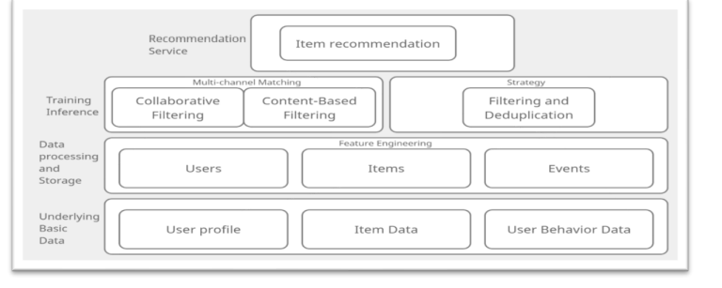

A solution architecture for a restaurant recommendation system can be divided into the following components:

**Data Layer:** This layer contains all of the data that is used to generate recommendations, such as user profiles, restaurant information, and user ratings and reviews. The data can be stored in a variety of ways, such as a relational database, a NoSQL database, or a data warehouse.

**Recommendation Engine:** This layer contains the algorithms that are used to generate recommendations. There are a variety of different recommendation algorithms available, such as collaborative filtering, content-based filtering, and hybrid approaches.

**API Layer:** This layer provides an interface for the recommendation engine to be accessed by other applications. The API can be implemented using a variety of different technologies, such as HTTP, REST, or GraphQL.

**User Interface:** This layer provides a user interface for users to interact with the recommendation system. The user interface can be implemented as a web application, a mobile app, or a desktop application.

**Deployment Architecture:** This layer describes how the system will be deployed and scaled. The system can be deployed on-premises, in the cloud, or using a hybrid approach.

**PROJECT PLANNING & SCHEDULING**

**Technical Architecture**

The technical architecture of a restaurant recommendation system can be divided into the following components:

Data Layer: This layer contains all of the data that is used to generate recommendations, such as user profiles, restaurant information, and user ratings and reviews. The data can be stored in a variety of ways, such as a relational database, a NoSQL database, or a data warehouse.

Recommendation Engine: This layer contains the algorithms that are used to generate recommendations. There are a variety of different recommendation algorithms available, such as collaborative filtering, content-based filtering, and hybrid approaches.

API Layer: This layer provides an interface for the recommendation engine to be accessed by other applications. The API can be implemented using a variety of different technologies, such as HTTP, REST, or GraphQL.

User Interface: This layer provides a user interface for users to interact with the recommendation system. The user interface can be implemented as a web application, a mobile app, or a desktop application.

Deployment Architecture: This layer describes how the system will be deployed and scaled. The system can be deployed on-premises, in the cloud, or using a hybrid approach.

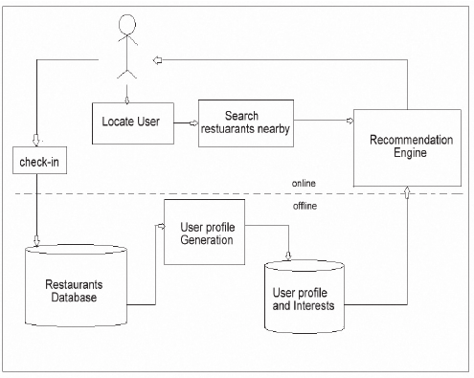

**Sprint Planning & Estimation**

Here is a sample sprint planning and estimation for a restaurant recommendation system:

Sprint 1

Objective: Develop a prototype of the restaurant recommendation system.

Tasks:

* Set up the development environment
* Design the database schema
* Implement the data layer
* Implement the recommendation engine
* Implement the API layer
* Develop a basic user interface

Estimated effort: 2 weeks

Sprint 2

Objective: Enhance the prototype and add new features.

Tasks:

* Add support for user authentication and authorization
* Implement additional recommendation algorithms
* Add support for filtering and sorting recommendations
* Improve the accuracy of the recommendations
* Enhance the user interface

Estimated effort: 2 weeks

Sprint 3

Objective: Beta test the system and fix any bugs.

Tasks:

* Deploy the system to a beta testing environment
* Invite a group of users to beta test the system
* Collect feedback from the beta testers
* Fix any bugs that are found

Estimated effort: 2 weeks

Sprint 4

Objective: Release the system to production.

Tasks:

* Deploy the system to the production environment
* Configure the system for monitoring and logging
* Market the system to potential users

Estimated effort: 2 weeks

Total estimated effort: 8 weeks

6.3 Sprint Delivery Schedule

Sprint 1

Week 1

* Set up the development environment
* Design the database schema
* Implement the data layer

Week 2

* Implement the recommendation engine
* Implement the API layer
* Develop a basic user interface

Sprint 2

Week 1

* Add support for user authentication and authorization
* Implement additional recommendation algorithms
* Add support for filtering and sorting recommendations

Week 2

* Improve the accuracy of the recommendations
* Enhance the user interface

Sprint 3

Week 1

* Deploy the system to a beta testing environment
* Invite a group of users to beta test the system

Week 2

* Collect feedback from the beta testers
* Fix any bugs that are found

Sprint 4

Week 1

* Deploy the system to the production environment
* Configure the system for monitoring and logging

Week 2

* Market the system to potential users

**ADVANTAGES & DISADVANTAGES**

**Advantages:**

Personalization:

Provides personalized restaurant recommendations based on user preferences, improving user satisfaction.

Time Efficiency:

Saves time for users by offering quick and relevant restaurant suggestions, eliminating the need for extensive manual searches.

Enhanced User Experience:

Creates a positive user experience by offering tailored recommendations, which can lead to increased user engagement and loyalty.

Increased Sales for Restaurants:

Helps restaurants attract more customers by promoting them to users who are likely to enjoy their offerings.

Data-Driven Insights:

Generates valuable data on user preferences and behavior, enabling businesses to make informed decisions and improve their services.

Adaptability:

Can adapt to changing user preferences and trends, ensuring that recommendations remain relevant over time.

**Disadvantages:**

Over-Reliance on Algorithms:

May result in limited diversity in recommendations if users are consistently guided by the same algorithms, potentially missing out on hidden gems.

Privacy Concerns:

Collecting and utilizing user data for recommendations raises privacy concerns, and users may be hesitant to share personal information.

Bias in Recommendations:

Recommendations may be biased towards popular or well-known restaurants, potentially overshadowing smaller establishments.

Algorithmic Errors:

Algorithms can make mistakes, leading to inaccurate recommendations that may not align with users' preferences.

Dependence on User Feedback:

Relies on user feedback for continuous improvement, and if users do not provide feedback, the system may struggle to enhance its accuracy.

Resistance to Change:

Users may resist adopting or trusting the system, particularly if they prefer making restaurant choices based on personal recommendations or traditional methods.

**Conclusion**

Restaurant recommendation systems have the potential to revolutionize the way people find and enjoy food. By using data and machine learning, these systems can provide users with personalized recommendations that are tailored to their individual preferences.

Restaurant recommendation systems can be used by a variety of stakeholders, including individual diners, restaurants, and food delivery companies. For individual diners, restaurant recommendation systems can help them to discover new restaurants and cuisines that they may not have otherwise considered. For restaurants, restaurant recommendation systems can help them to reach new customers and increase sales. For food delivery companies, restaurant recommendation systems can help them to optimize their delivery routes and improve the customer experience.

benefits of restaurant recommendation systems

* Personalized recommendations: Restaurant recommendation systems can provide users with personalized recommendations based on their individual preferences. This can help users to discover new restaurants and cuisines that they may not have otherwise considered.
* Time savings: Restaurant recommendation systems can save users time by eliminating the need to search for restaurants on their own. Instead, users can simply provide the system with their preferences and the system will generate a list of recommendations.
* Increased customer satisfaction: Restaurant recommendation systems can help restaurants to increase customer satisfaction by providing customers with a better dining experience. For example, a restaurant recommendation system can recommend restaurants that are close to the user's location and that offer food that matches the user's preferences.
* Improved food delivery: Restaurant recommendation systems can help food delivery companies to improve the customer experience by recommending restaurants that are close to the user's delivery address and that offer food that matches the user's preferences.

**FUTURE SCOPE :**

Restaurant recommendation systems are still a relatively new technology, but they are rapidly evolving. In the future, we can expect to see restaurant recommendation systems that are even more personalized, accurate, and efficient. One of the key trends in restaurant recommendation systems is the use of artificial intelligence (AI). AI can be used to develop more sophisticated recommendation algorithms that take into account a wider range of factors, such as the user's past dining history, the reviews of other users, and the availability of restaurants. Another trend in restaurant recommendation systems is the use of location data. Location data can be used to recommend restaurants that are close to the user's current location or that are on their route to their destination. Finally, we can expect to see restaurant recommendation systems that are integrated with other food-related services, such as food delivery and meal planning. This will make it even easier for users to find and enjoy the food that they want. Overall, the future of restaurant recommendation systems is very bright. With the continued development of AI and location data, restaurant recommendation systems will become even more powerful and useful tools for diners, restaurants, and food delivery companies.

**Source code and the outputs :**

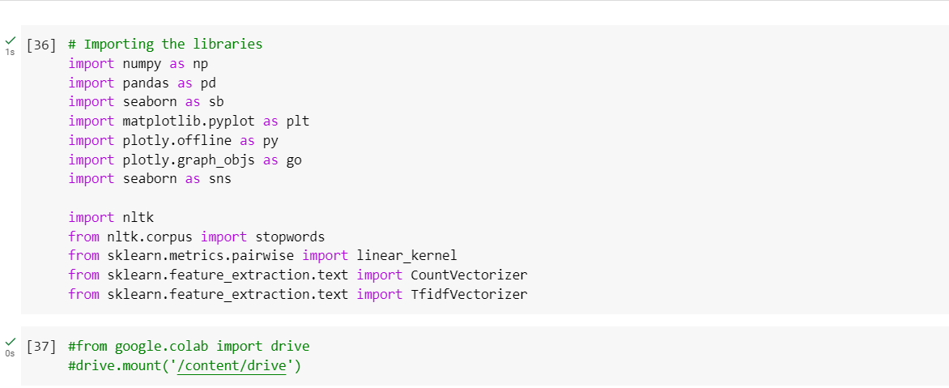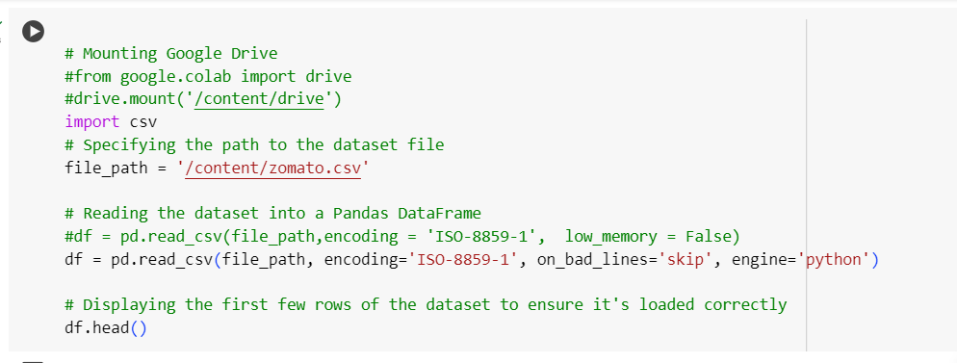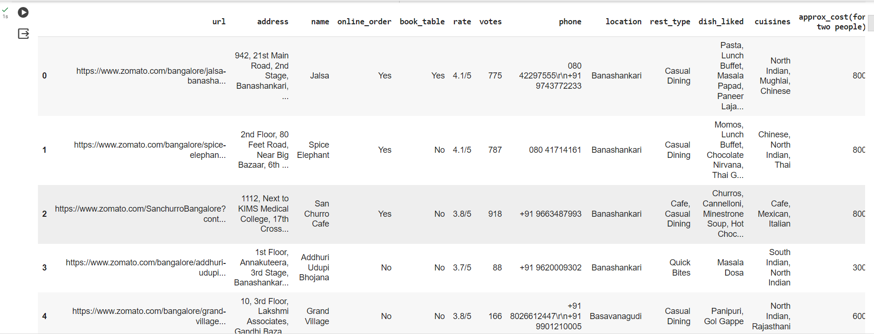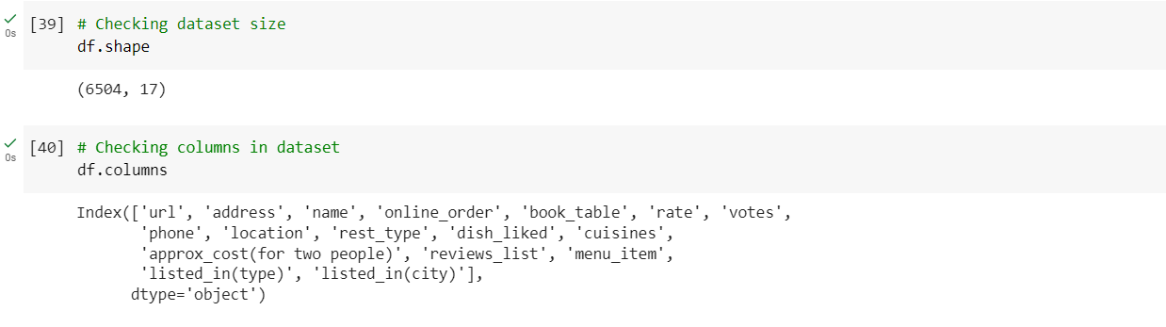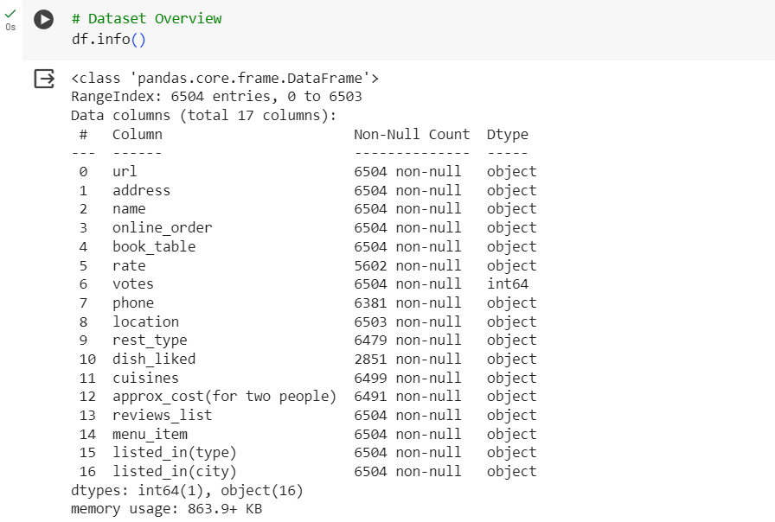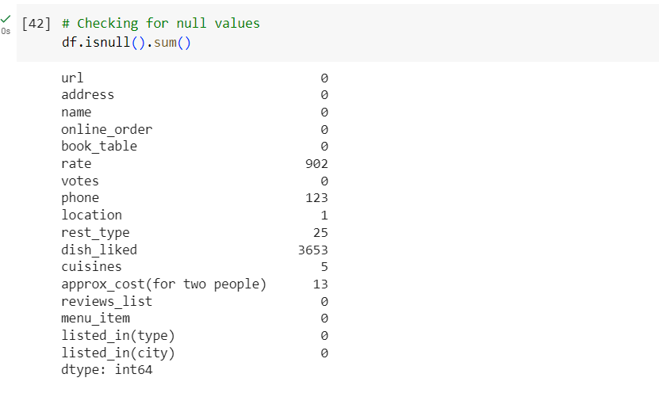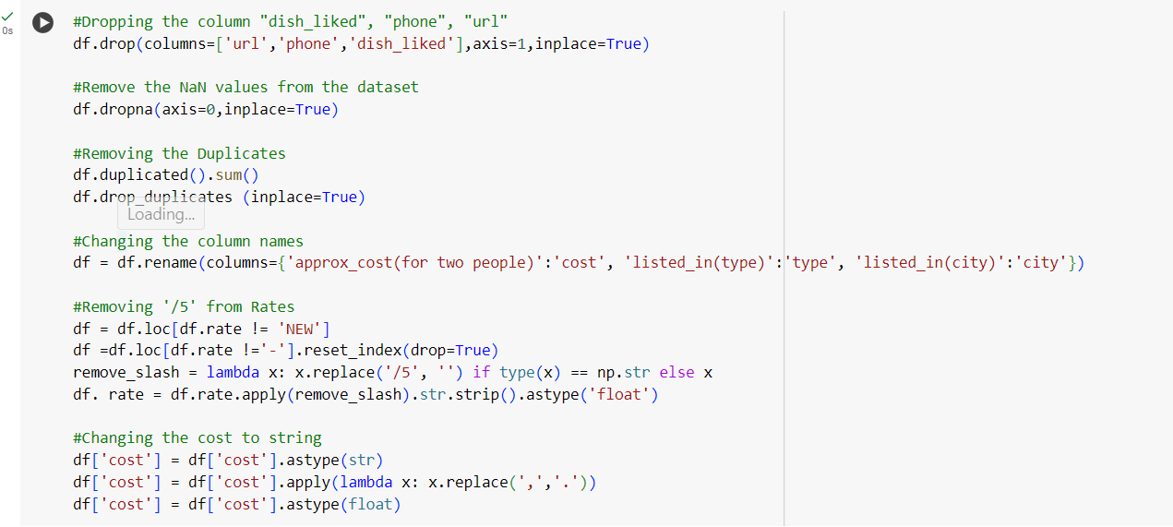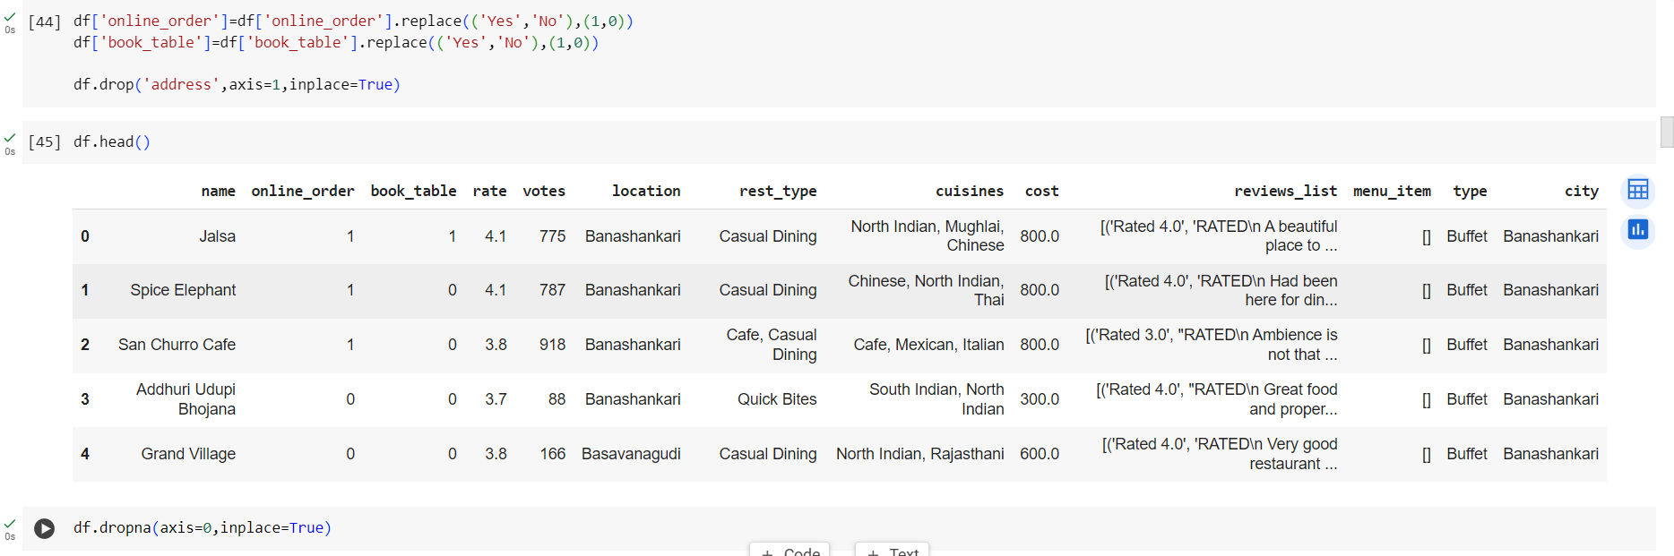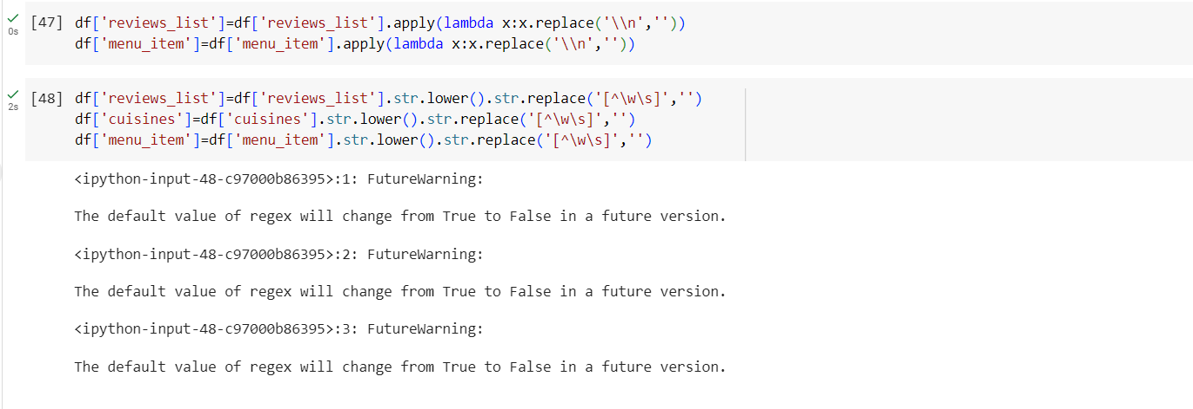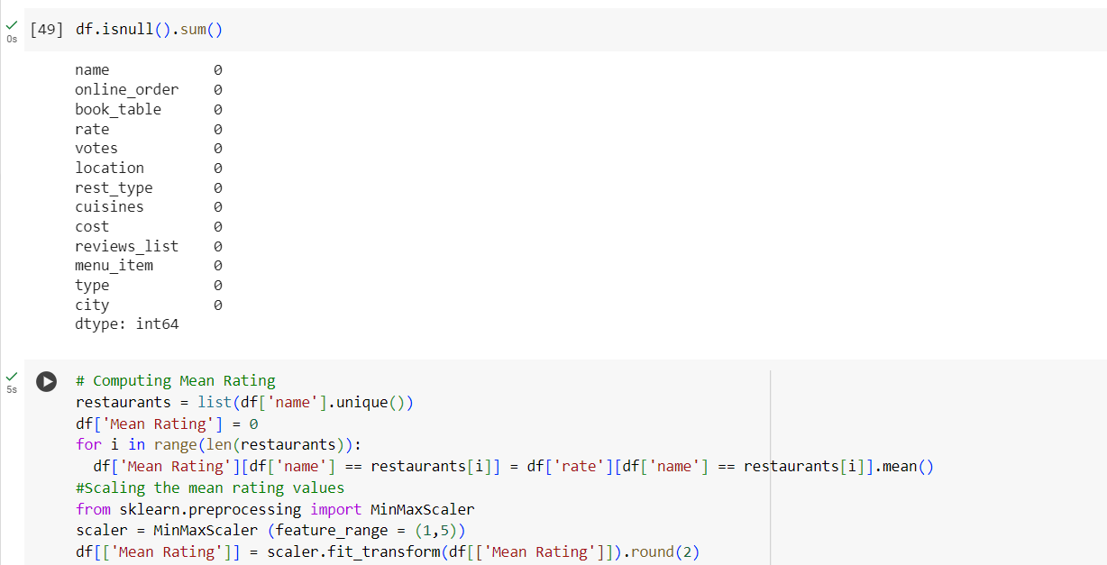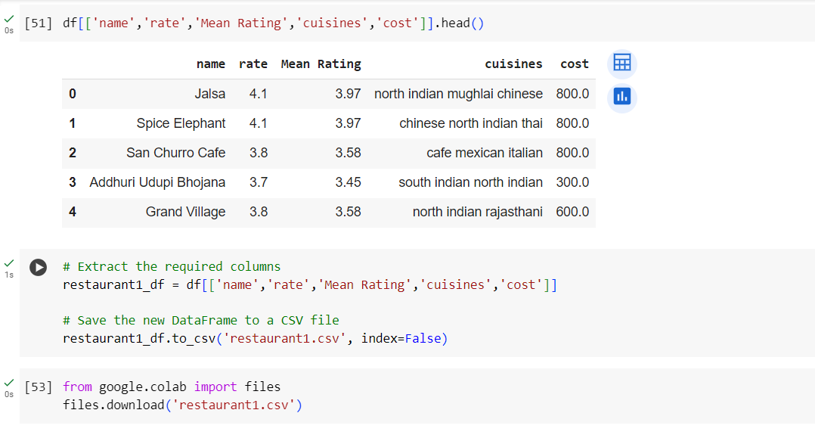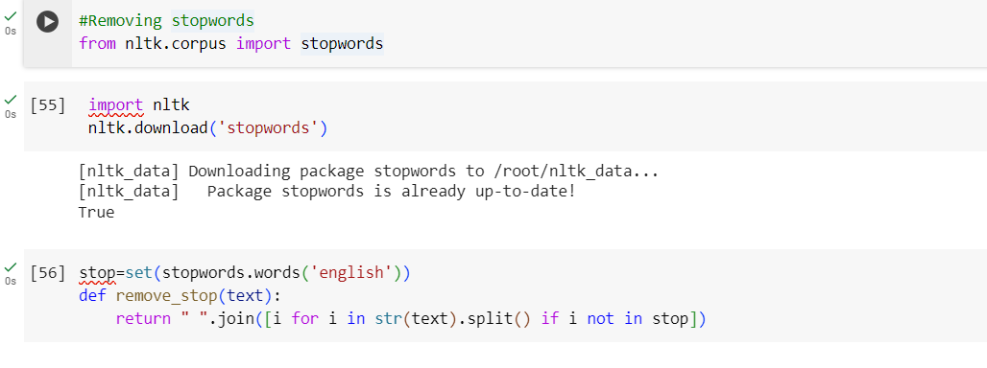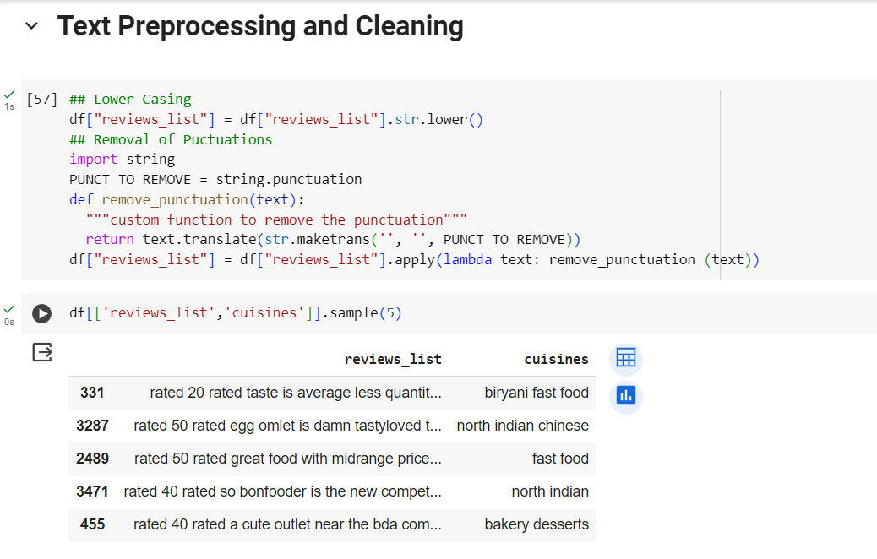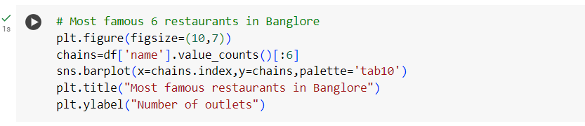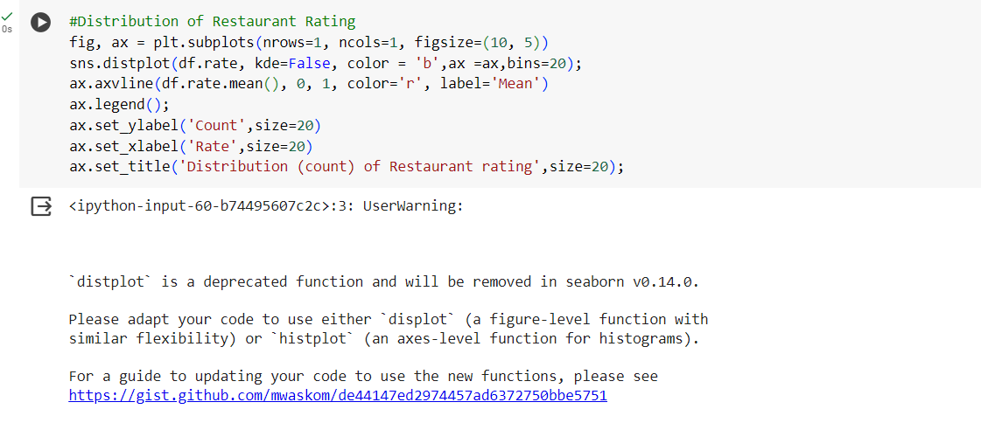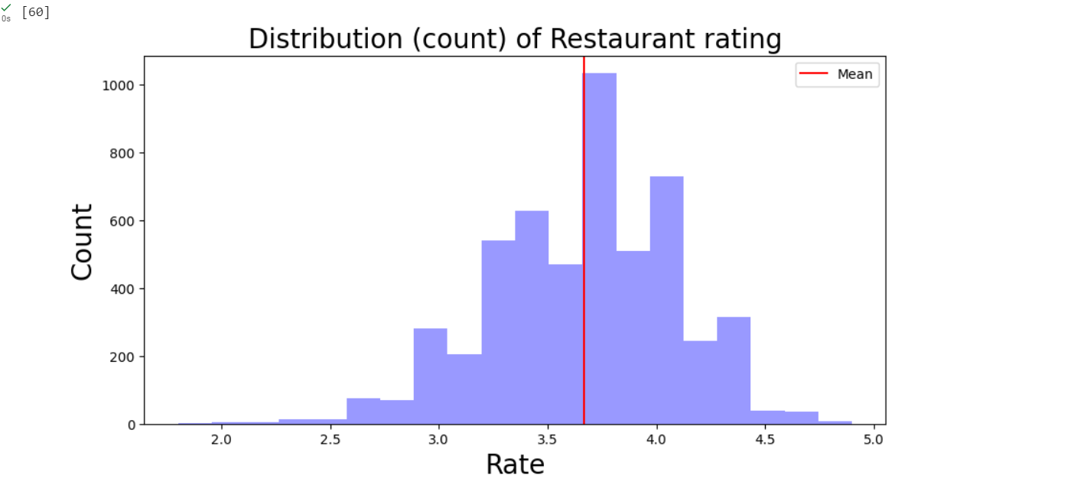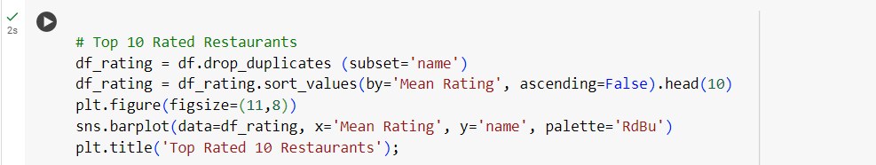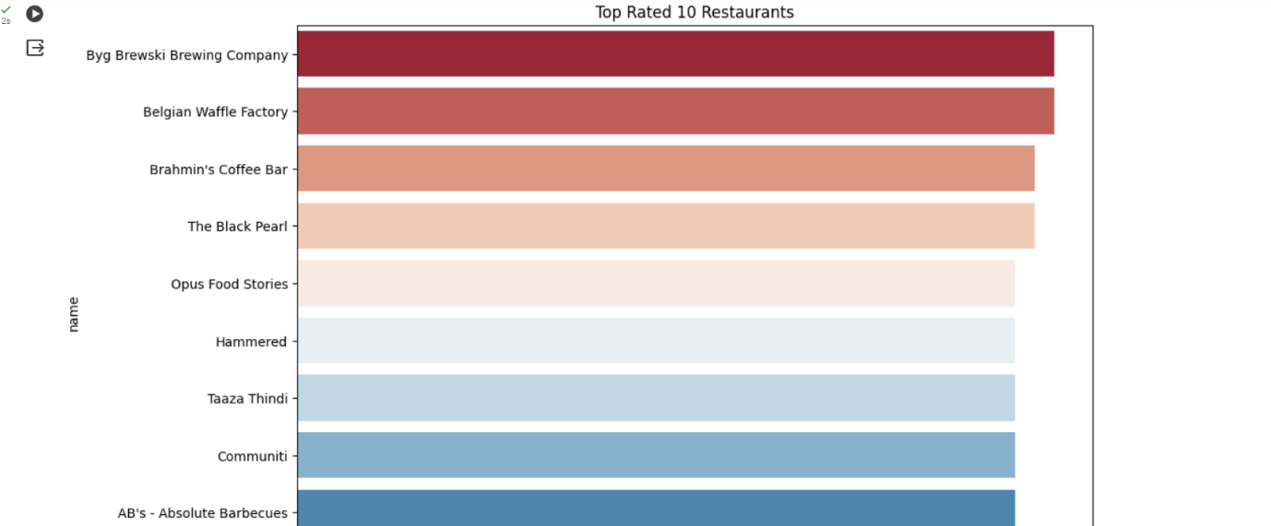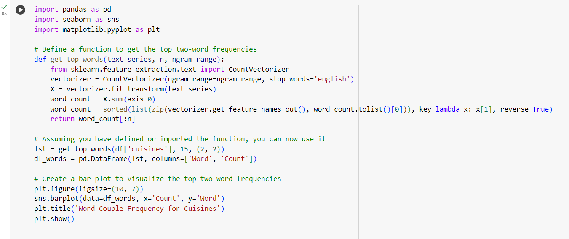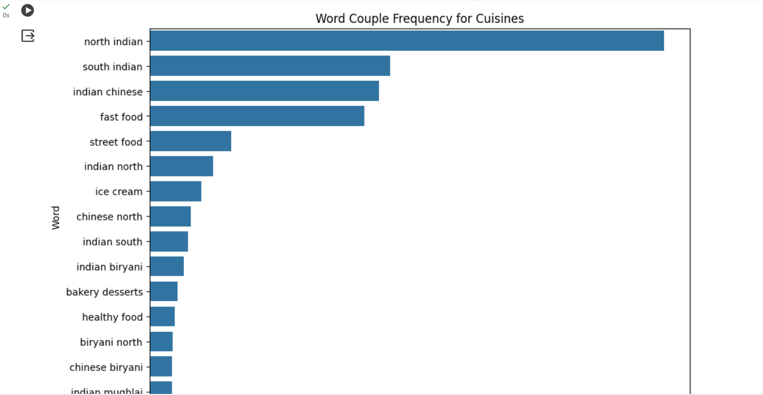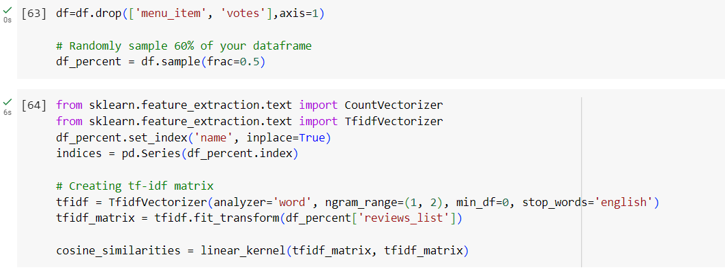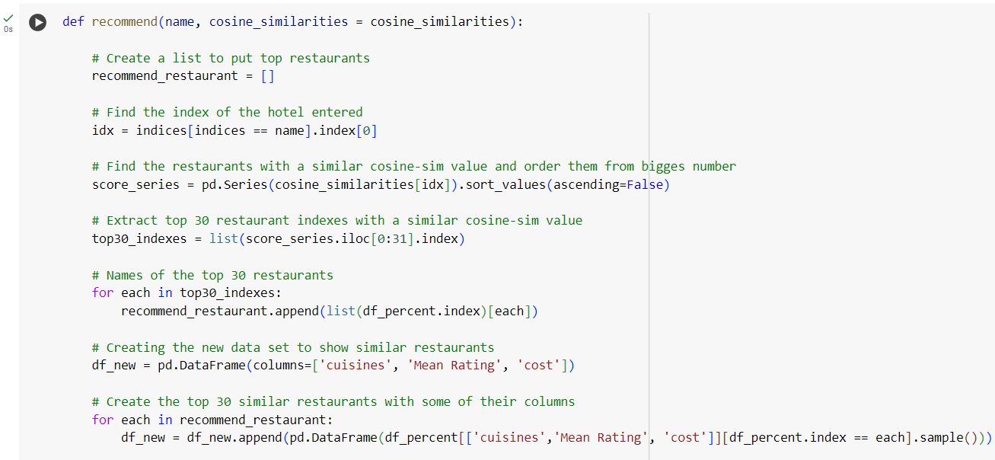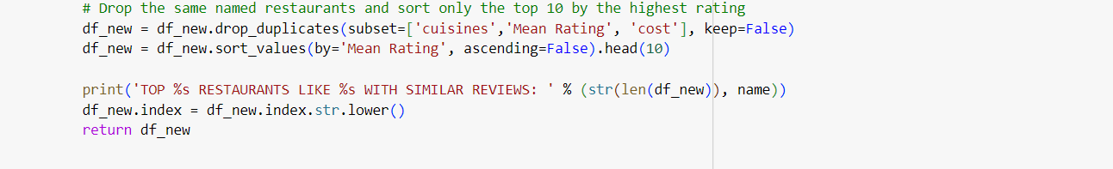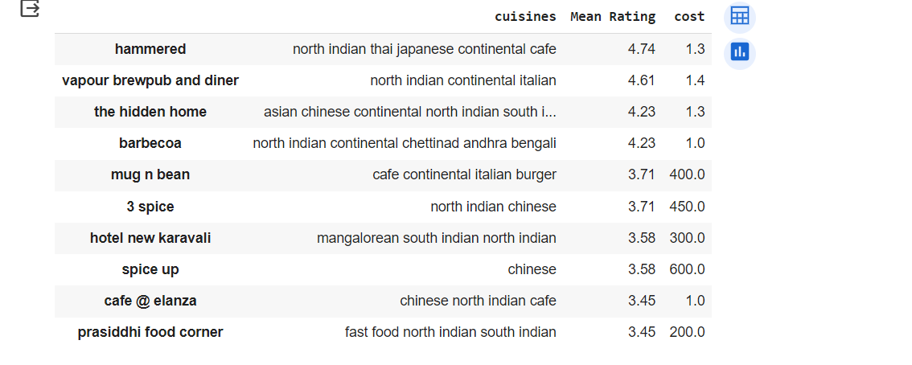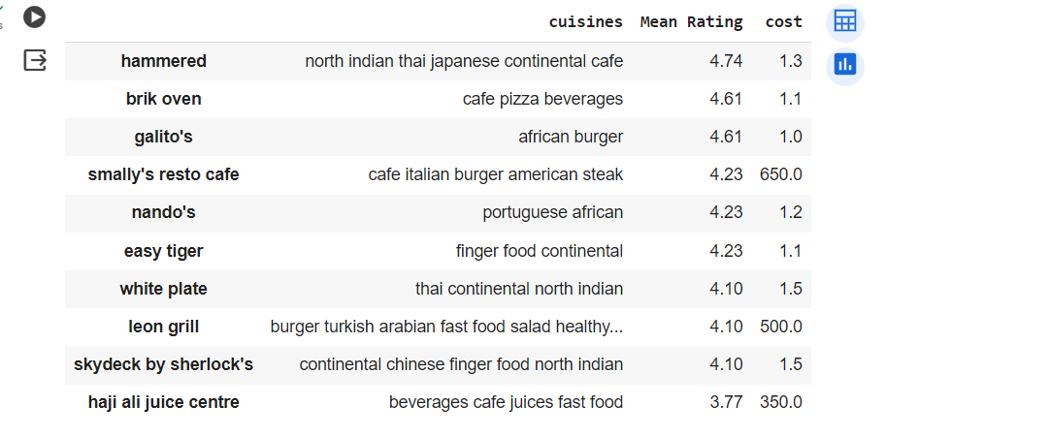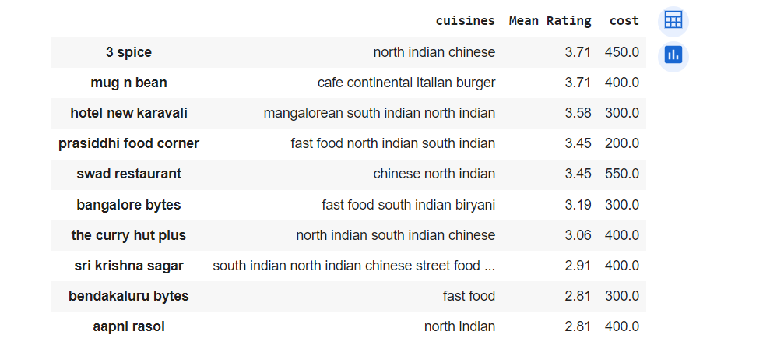

Demo Video :

<https://drive.google.com/file/d/1BlYnUGYHkWNsAPKjEDrcGT1vOPLQGg1H/view?usp=sharing>